Pigs

The pig herd consists of mating sows, pregnant sows, lactating sows (including suckling piglets up to weaning), weaners, finishers and replacement sows. The pig production is modelled as a steady state process rather than following the cycles of production. The production statistics (e.g. growth per day, length of production cycle) are inputs to the pig module; the main function of the module is to partition nutrients between urine and faeces.

The inputs to the model at the herd level are:
- the average number of production sows present during the year.
- the average number of live animals produced per litter per production sow.
- the time the production sows spend in each of the three phases.
- the annual production of piglets, baconers and replacement sows.
- the time spent by animals as piglets, baconers and replacement sows.

The maximum number of live animals produced per year from the system’s own resources depends on the length of the production sow cycle:

maximum number of live animals produced per year = (the number of live animals produced per litter per production sow cycle * days in year)/(the production sow cycle).

The sum of the annual production of piglets, baconers and replacement sows must always be equal or greater than this figure. If greater, additional animals are bought as suckling piglets. The average numbers of piglets, baconers and replacement sows present on any particular day are calculated as follows:

Number of piglets = (production of piglets + production of baconers + production of replacement sows) * duration of growth stage/days in year
Number of baconers = (production of piglets + production of baconers) * duration of growth stage/days in year
Number of replacement sows = production of replacement sows * duration of growth stage/days in year

3.1.1 Sows

Production sows are considered to cycle through three phases; mating, pregnancy and lactating. In each of these phases, the sows can receive different feed mixtures and can be housed in different sections of the animal house. Although the latter has no effect on the sows, it means that the manure they produce can be routed separately, if necessary. The length of the sow production cycle is the sum of the duration of the three phases.

3.1.1.1 Nitrogen

The production sows partition the N received in their diet between growth, urine and faeces (Fig 2).
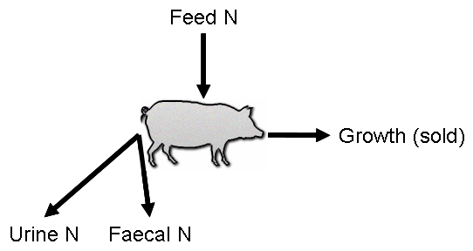

Fig 2 Partitioning of nitrogen in pigs

For pregnant sows, the growth includes the growth of the foetus. For lactating sows, growth and the manure produced includes the contribution to and from the suckling piglets:

Growth N per sow per day = (N concentration (end) * weight (end) - N concentration (start) * weight (start))/ production sow cycle

Growth N of mating sows = Growth N per sow per day

Growth N of pregnant sows and growth of lactating sows = Growth N per sow per day + total weight of N in piglets at weaning/(duration of pregnancy + duration of lactation)

The excretion of N and its partitioning between urine and faeces is calculated as follows:

Digested N = feed intake * (protein N concentration * protein digestibility + concentration of N - protein N concentration)

Urine N = digested N – growth N per day for relevant category

Faeces N = feed intake * protein N concentration * (1- protein digestibility)

If the digested N is less than the growth N per day for relevant category then the model stops and flags an error.

3.1.2 Piglets, finishers and replacements

The partitioning of N is calculated as for production sows, except for growth N, which is calculated as:

Growth N per animal per day = (N concentration (end) * weight (end) - N concentration (start) * weight (start))/ duration of growth stage

3.1.3 Pig feeding

The diet of the production sows in each of the production phases is input as an amount or amounts of a range of predefined feedstuffs. The following information concerning each feedstuff is input; concentration of N, concentration of protein N, digestibility of protein. The value of these variables in the diet is calculated as the weighted mean of the contributing feedstuffs

